[Course View Details]

Technical Document

Date: 13/Feb/2019

Version: Version 0.1

# Table of Contents

Table of Contents 1

[Task Name] 2

Description 2

1.1 Mockup screen: 2

1.2 Angular & Spring Models 2

1.3 Angular Component 3

1.4 Rest Services 3

1.5 Flow Services: 3

1.6 Repository Functions 3

# [View Course Details]

Refer to: [Taiga URL]

## Description

Write the Task Description Here

## Mockup screen:

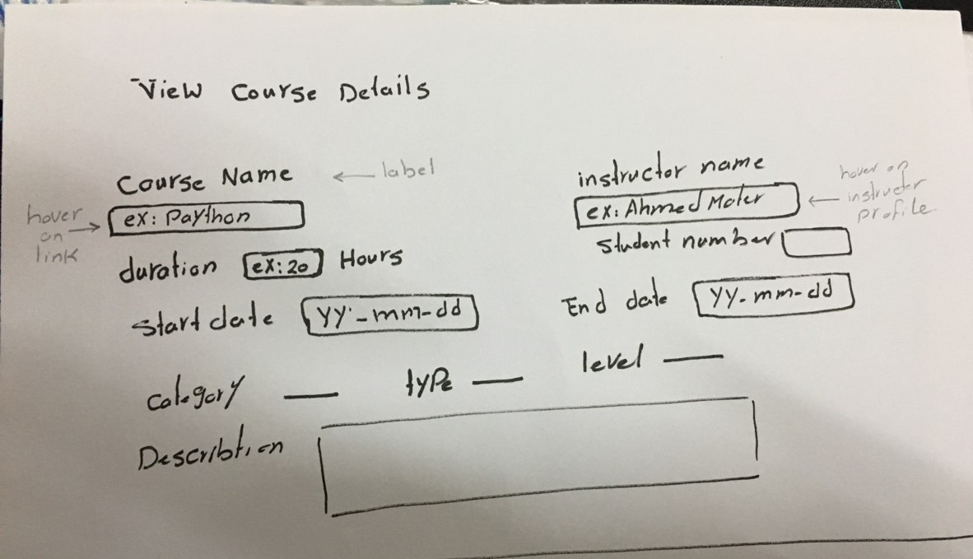

## Angular & Spring Models

|  |  |  |  |
| --- | --- | --- | --- |
| **New** | **Class Name** | CourseVTO | |
| **Angular Path** | | app/modules/course/shared/data/course-vto.ts | |
| **Spring Path** | | model/course/CourseVTO.java | |
| **Fields** | | | |
| **Attribute** | | **Angular Data Type** | **Spring Data Type** |
| corCategory | | String | String |
| corType | | String | String |
| corLevel | | String | String |
| instructorName | | string | String |
| studentNum | | number | Int |
| courseName | | String | String |
| duration | | number | Int |
| startDate | | Date | Date |
| endDate | | Date | Date |
| description | | String | String |

|  |  |  |
| --- | --- | --- |
| **New** | **Class Name** | CourseVTORM |
| **Spring Path** | | model\ course \rm\CourseVTORM.java |
| **Fields** | | |

## Angular Component

|  |  |  |
| --- | --- | --- |
| **New** | **Class Name** | ViewCourseComponent |
| **Path** | | modules\course\components\course\view-course |

|  |  |  |
| --- | --- | --- |
| **New** | **Class Name** | CourseService |
| **Path** | | modules\course\shared\services\course.service.ts |
| **Function** | | getCourseByID(corID) |

## Rest Services

|  |  |  |  |  |  |  |  |
| --- | --- | --- | --- | --- | --- | --- | --- |
| **New** | **Name** | | api/course/{corID} | | | **Method** | GET |
| **Controller** | | | CourseRes | | | **Function** | viewCourse(corID) |
| **REST Parameter** | | | | | | | |
| **Attribute** | | **Parameter Type** | | **Data Type** | **Description** | | |
| .corID | | Path Parameter | | int |  | | |

## Repository Functions

|  |  |  |  |  |
| --- | --- | --- | --- | --- |
| **New** | **Class Name** | CourseRep | **Type** | Select SQL |
| **Function** | | findByID(corID) | | |
| **Query** | | | | |
| USE sms ;  SELECT c.cor_name , c.duration , c.start_date, c.end_date, concat(u.first_name,u.last_name)  as Instructor_Name, c.description ,COALESCE(t.cat_count, 0) AS student_number , g.label_en cor_category ,  cor_t.label_en cor_type , l.label_en cor_level  FROM course c  lEFT JOIN auth_user u ON c.instructor_id = u.id  lEFT JOIN cor_category g ON c.category_id = g.id  lEFT JOIN cor_type cor_t ON c.type_id = cor_t.id  lEFT JOIN cor_level l ON c.level_id = l.id  LEFT JOIN  (  SELECT cor_id , COUNT(*) AS cat_count  FROM course_std  GROUP BY cor_id  ) t ON c.id = t.cor_id  WHERE c.id = ? ; | | | | |